

**PRACTICAL FILE**

COMPUTER SCIENCE

CLASS: XI Science

Department Of Computer Science

Rabindra Vidya Niketan, NH-49, Keonjhar, Odisha

Name : RITIK KUMAR BARIK

ROLL NO :

CERTIFICATE

Name: _____________________ Class: XI Science

Roll No: ______ Exam : AISSCE 2021

Institution: Rabindra Vidya Niketan, Keonjhar, Odisha

*This is certified to be the bonafide work of the student in the* ***Computer Science Laboratory*** *during the academic year* ***2020-21****.*

*No. of practical certified ___________ out of ____________ in the subject of* ***Computer Science****.*

*Teacher In-Charge*

*Date:_______________*

I N D E X

|  |  |  |  |  |  |
| --- | --- | --- | --- | --- | --- |
| Sl. No. | Name of the practical | Page No. | Date of Practical | Date of Submission | Signature |
|  |  |  |  |  |  |
|  |  |  |  |  |  |
|  |  |  |  |  |  |
|  |  |  |  |  |  |
|  |  |  |  |  |  |
|  |  |  |  |  |  |
|  |  |  |  |  |  |
|  |  |  |  |  |  |
|  |  |  |  |  |  |
|  |  |  |  |  |  |
|  |  |  |  |  |  |
|  |  |  |  |  |  |
|  |  |  |  |  |  |
|  |  |  |  |  |  |
|  |  |  |  |  |  |
|  |  |  |  |  |  |
|  |  |  |  |  |  |
|  |  |  |  |  |  |
|  |  |  |  |  |  |
|  |  |  |  |  |  |
|  |  |  |  |  |  |
|  |  |  |  |  |  |
|  |  |  |  |  |  |
|  |  |  |  |  |  |

|  |  |  |  |  |  |
| --- | --- | --- | --- | --- | --- |
| Sl. No. | Name of the practical | Page No. | Date of Practical | Date of Submission | Signature |
|  |  |  |  |  |  |
|  |  |  |  |  |  |
|  |  |  |  |  |  |
|  |  |  |  |  |  |
|  |  |  |  |  |  |
|  |  |  |  |  |  |
|  |  |  |  |  |  |
|  |  |  |  |  |  |
|  |  |  |  |  |  |
|  |  |  |  |  |  |
|  |  |  |  |  |  |
|  |  |  |  |  |  |
|  |  |  |  |  |  |
|  |  |  |  |  |  |
|  |  |  |  |  |  |
|  |  |  |  |  |  |
|  |  |  |  |  |  |
|  |  |  |  |  |  |
|  |  |  |  |  |  |
|  |  |  |  |  |  |
|  |  |  |  |  |  |
|  |  |  |  |  |  |
|  |  |  |  |  |  |
|  |  |  |  |  |  |

*Teacher’s Signature*

**PFQ01.**

**Write a python program that accepts radius of circle and print its area.**

PROGRAM:

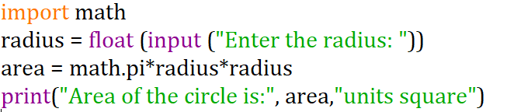

OUTPUT:

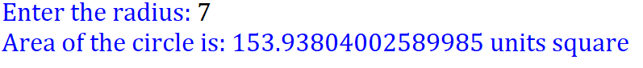

**PFQ 02.**

**Write a python program to calculate the Simple Interest and Compound Interest based on Principal amount, rate and time entered by the user.**

PROGRAM:

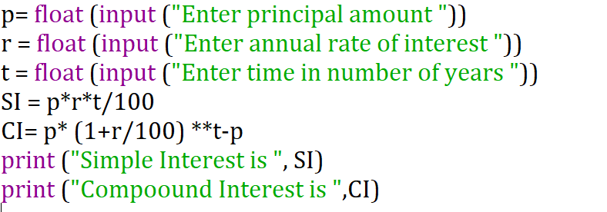

OUTPUT:

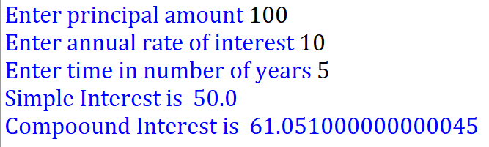

**PFQ 03:**

**Write python program that inputs a students’s marks in three subjects (out of 100) and print the percentage marks.**

PROGRAM:

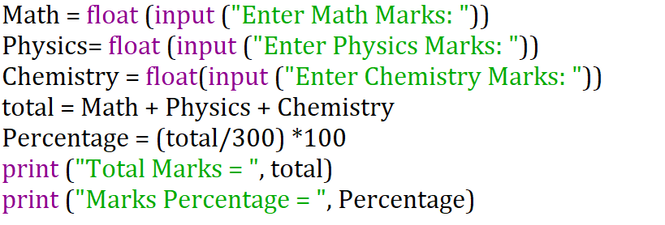

OUTPUT:

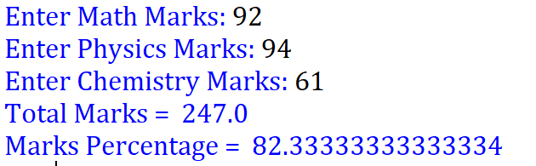

**PFQ 04:**

**Write a python program to compute area of square and triangle**

PROGRAM:

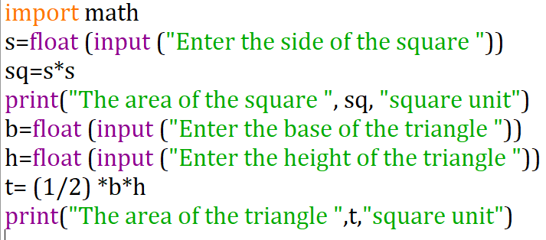

OUTPUT:

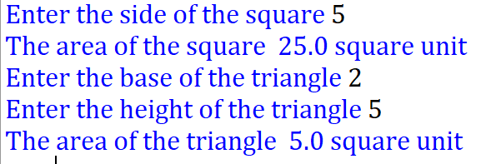

**PFQ 05:**

**Write a Python program to accept two numbers and print their quotient and remainder.**

PROGRAM:

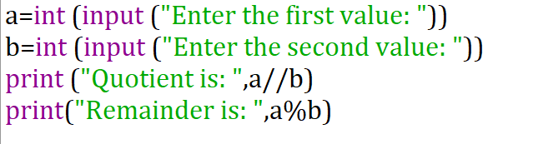

OUTPUT:

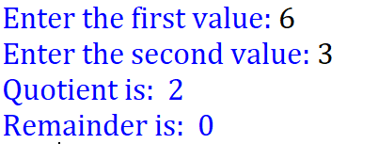

**PFQ 06:**

**Write a Python program to accepts three integers and print the largest of the three.**

PROGRAM:

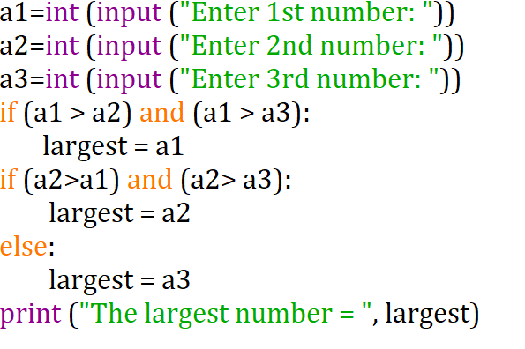

OUTPUT:

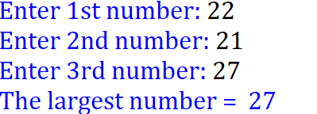

**PFQ 07:**

**Write a Python program to accept a number and check the number is prime or not.**

PROGRAM:

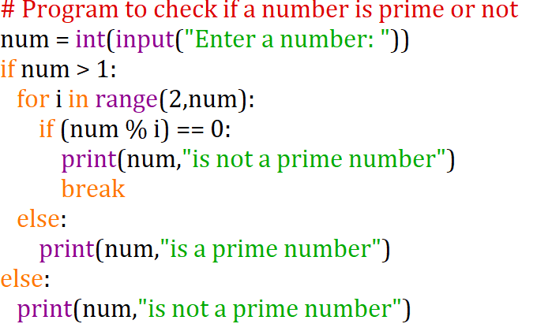

OUTPUT:

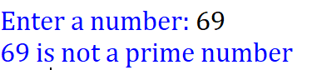

**PFQ 08:**

**Write a Python program to reads two numbers and an operator and displays the computed result.**

PROGRAM:

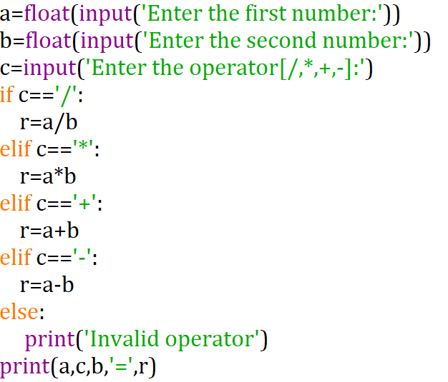

OUTPUT:

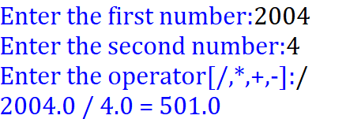

**PFQ09:**

**Write a Python program to calculate the factorial of a number**

PROGRAM:

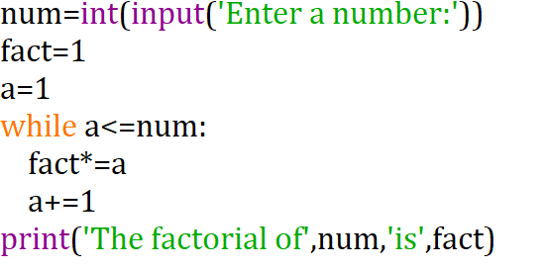

OUTPUT:

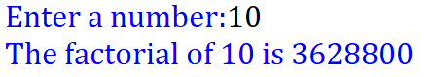

**PFQ10.**

**Write a program to input a number and check if it is a prime number. (use for loop)**

PROGRAM:

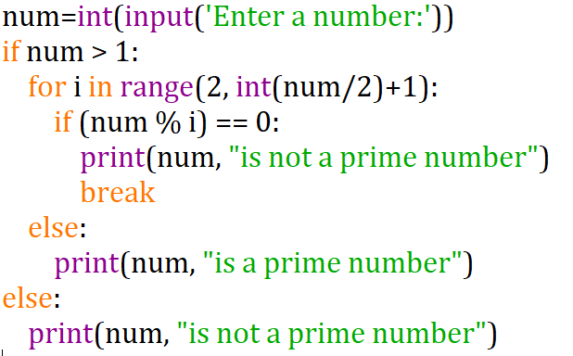

OUTPUT:

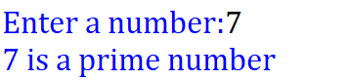

**PFQ11:**

**Write a program to print the pattern. (using nested for loop)**

*

* *

* * *

* * * *

* * * * *

PROGRAM:

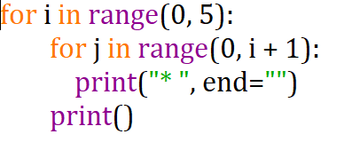

OUTPUT:

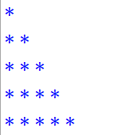

**PFQ12.**

**Write a program to print Fibonacci Series for first 20 elements. (use for loop)**

0 1 1 2 3 5 8 …

PROGRAM:

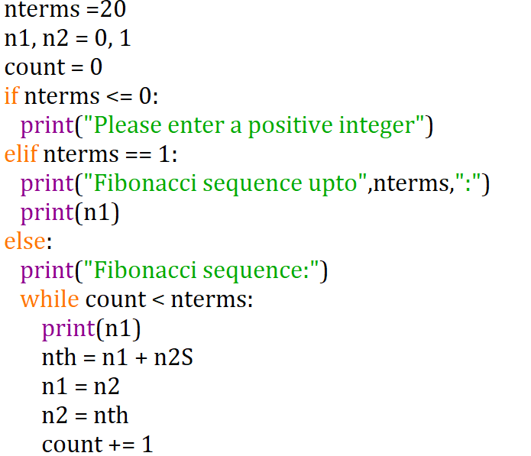

OUTPUT:

